2022 Atlantic Hurricane Season Begins
Start of Hurricane Season is a Reminder to Prepare

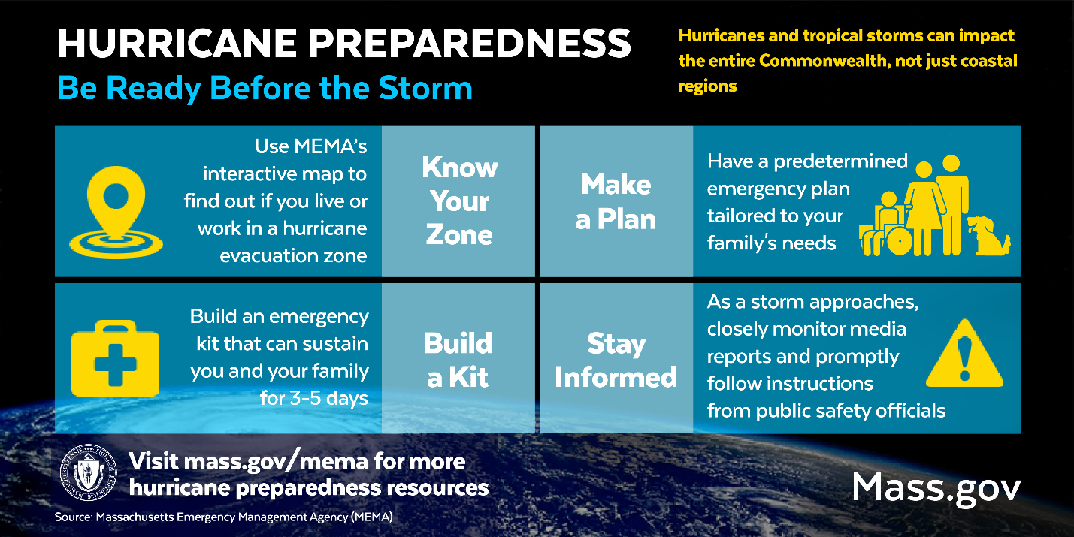

FRAMINGHAM – June 1 marks the start of the 2022 Atlantic Hurricane Season, which extends through November 30.

The National Oceanic and Atmospheric Administration’s (NOAA) seasonal outlook predicts another active, above-normal, Atlantic hurricane season – the seventh consecutive above-normal hurricane season. According to the National Hurricane Center, last year was the third most active year on record with 21 named storms.

“Regardless of the seasonal outlook, it only takes one storm to severely impact an area. Tropical cyclones can bring storm surge flooding to coastal areas and damaging winds, destructive flooding, and severe weather to the entire state, so residents in all parts of Massachusetts should prepare for hurricane season,” said Massachusetts Emergency Management Agency (MEMA) Acting Director Dawn Brantley. “Throughout hurricane season, MEMA will continue to plan with our partners, provide preparedness resources, and ensure that the Commonwealth is ready to respond to any storms that may threaten us.”

How Residents Can Prepare
- Know Your Evacuation Zone - Learn if you live or work in a hurricane evacuation zone: www.mass.gov/knowyourzone. If you live in an area that may flood and may need assistance evacuating, plan with family, neighbors, and friends who may be able to assist, and contact your local public safety officials to make them aware of your needs.
- Make an Emergency Plan – Have an emergency plan of how your family would communicate, evacuate, and shelter in place that addresses the needs of all of your family members, including seniors, children, individuals with access and functional needs, and pets: https://www.mass.gov/info-details/make-a-family-emergency-plan. If you receive medical treatment or home health care services, work with your medical provider to determine how to maintain care and service if you are unable to leave your home or have to evacuate.
- Build an Emergency Kit - Build an emergency kit that will sustain your household for three to five days without power: https://www.mass.gov/info-details/build-an-emergency-kit.
- Stay Informed - Every family should have multiple methods for receiving emergency alerts. Learn more about different types of alerting and information tools including the Emergency Alert System, Wireless Emergency Alerts, NOAA Weather Radio, social and traditional news media, Mass 2-1-1 and local notification systems: https://www.mass.gov/info-details/be-informed-and-receive-emergency-alerts.

Throughout hurricane season, MEMA will share preparedness and safety information to help residents be aware of, and prepare for, the impacts of hurricanes and tropical storms. For more information, visit the Hurricane Safety Tips section of MEMA’s website at https://www.mass.gov/mema/hurricanes.

MEMA Hurricane Season Preparedness Activities
In anticipation of the 2022 hurricane season, MEMA has begun hurricane preparedness activities which will continue throughout the season:
- In May, MEMA facilitated a series of tabletop exercises for local officials to evaluate, validate, and improve their Comprehensive Emergency Management Plans (CEMPs). The exercises featured a hurricane scenario for participants to exercise the capabilities of their plans including planning, operational coordination, community resilience, infrastructure, public information and warning.
- On May 24, MEMA and Emergency Support Function (ESF) partners participated in a regional hurricane exercise with several other New England states. The exercise included a briefing from the National Hurricane Center, discussions with the National Weather Service, and a scenario that led to coordination and cooperation from response agencies on key priorities and actions. The exercise also helped identify areas of focus for additional response planning.
- MEMA will convene meetings with representatives from ESF partner agencies to update plans for distribution of critical commodities, communications, debris management, electricity and utility restoration, evacuations, fuel supplies and distribution, sheltering, mass feeding, impact assessments, search and rescue, and operation of logistics support areas.

About MEMA
MEMA is the state agency charged with ensuring the state is prepared to withstand, respond to, and recover from all types of emergencies and disasters, including natural hazards, accidents, deliberate attacks, and technological and infrastructure failures. MEMA's staff of professional planners, communications specialists and operations and support personnel is committed to an all hazards approach to emergency management. By building and sustaining effective partnerships with federal, state and local government agencies, and with the private sector - individuals, families, non-profits and businesses - MEMA ensures the Commonwealth's ability to rapidly recover from large and small disasters by assessing and mitigating threats and hazards, enhancing preparedness, ensuring effective response, and strengthening our capacity to rebuild and recover. For additional information about MEMA and Emergency Preparedness, go to www.mass.gov/mema.

Continue to follow MEMA updates on Twitter at www.twitter.com/MassEMA; Facebook at www.facebook.com/MassachusettsEMA and YouTube at www.youtube.com/MassachusettsEMA.

